Article
Reproducibility-First Machine Learning Pipeline for Single-Cell RNA-Seq Variant-Derived Classification: Systematic Evaluation of Split Sensitivity, Cohort-Frequency Filtering, and Expression–Mutation Correlation in Wound Healing
Aidyn Kunikeyev¹, Amangeldi Salybekov², Aigerim Yerimbetova^{3,4} and Batyrkhan Omarov⁵
Academic Editor: Firstname Lastname
Received: date
Revised: date
Accepted: date
Published: date
Copyright: © 2026 by the authors. Submitted for possible open access publication under the terms and conditions of the Creative Commons Attribution (CC BY) license.
- Institute of Automation and Information Technologies, Satbayev University, Almaty, 050013, Kazakhstan; aidyn.daulet@gmail.com
- Regenerative Medicine Division, Cell and Gene Therapy Department, Qazaq Institute of Innovative Medicine, Astana, 010000, Kazakhstan; amansaab0@gmail.com
³ Institute of Information and Computational Technologies CS MSHE RK, Almaty, 050010, Kazakhstan; aigerian8888@gmail.com
⁴ School of Engineering and Information Technology, META University, Almaty, 050012, Kazakhstan
⁵ Department of Mathematical and Computer Modeling, International Information Technology University, Almaty, 050040, Kazakhstan; B.omarov@iitu.edu.kz
* correspondence: aigerian8888@gmail.com (A.Y.); aidyn.daulet@gmail.com (A.K.); +7 776 9889889
Abstract
Robust biomedical machine-learning (ML) studies require reproducible, auditable pipelines and rigorous split-aware validation to avoid inflated performance estimates caused by hidden inter-sample dependencies.
We analyzed public single-cell RNA-sequencing (scRNA-seq) data (BioProject PRJNA736095; 14 runs across 7 donors) using an end-to-end, fully reproducible workflow comprising STARsolo alignment, GATK HaplotypeCaller variant calling with hard-filter PASS export, cohort-frequency filtering, variant-to-gene feature engineering, repeated stratified cross-validation (5-fold × 30 repeats), permutation significance testing (200 permutations), and donor-grouped sensitivity analysis. An expression–mutation correlation module was added integrating Spearman rank correlations and hypergeometric marker-overlap enrichment with FDR correction.
Median variant records per sample were 139,422 (GATK-filtered) and 68,841 (cohort-filtered), yielding a median per-sample reduction of 53.83%. Feature dimensionality decreased by 8.60% (20,634 → 18,860 genes), while best repeated-CV balanced accuracy improved marginally from 0.9733 to 0.9800 (+0.67 pp). Permutation p-values were 0.00995 and 0.01493. Critically, donor-grouped evaluation reduced balanced accuracy from 0.9633 to 0.3571 (−62.9%), revealing strong split-protocol sensitivity. Spearman correlation showed positive associations between total gene burden, filtered records, and cohort-filtered records (ρ = 0.684–0.947). Marker-to-mutation overlaps were sparse and non-significant after FDR correction (minimum q = 0.631).
The primary contribution is a reproducibility-first ML framework that explicitly quantifies split sensitivity, donor-level generalization gaps, and expression–mutation relationships in small scRNA-seq cohorts. The pipeline demonstrates that high run-level classification performance is entirely consistent with near-chance donor-level generalization, and that transparent leakage-sensitivity reporting is essential for credible biomedical ML claims.
Keywords: scRNA-seq; variant calling; GATK HaplotypeCaller; feature engineering; machine learning; cross-validation; reproducibility; split sensitivity; donor-grouped evaluation; wound healing

1. Introduction
The intersection of single-cell sequencing technologies and machine learning offers unprecedented opportunities to characterize cellular heterogeneity in disease and injury contexts. However, the translation of high-performing computational classifiers into reproducible, interpretable biomedical findings remains a persistent challenge, particularly in studies characterized by small cohort size, high feature dimensionality, and non-independent biological replicates [1–6].
Wound healing represents a biologically complex process involving coordinated responses from fibroblasts, keratinocytes, endothelial cells, and immune cell populations. The ability to classify transcriptional states at single-cell resolution—distinguishing wound edge from unwounded skin—carries direct relevance for understanding the molecular basis of tissue repair. Recent single-cell atlases have delineated the spatiotemporal cellular dynamics of human skin wound healing with unprecedented resolution [7,8], including characterization of fibroblast heterogeneity between fibrotic and regenerative outcomes [9]. Expressed somatic variants, detectable through scRNA-seq variant calling, constitute an underexplored but potentially informative feature class that links genetic variation to transcriptional phenotype [10–12].
A critical and frequently underappreciated challenge in biomedical ML is the conflation of run-level performance with generalizable, donor-level discrimination. When multiple sequencing runs originate from the same biological donor, naïve stratified cross-validation will distribute run pairs across training and test splits, yielding optimistic estimates that do not reflect true out-of-donor generalization. This form of implicit data leakage has been documented across genomic classification benchmarks and represents a systematic risk when donor metadata are not incorporated into split design [13-15]. A recent survey found that data leakage affected at least 294 studies across 17 scientific fields, leading to systematically overoptimistic performance claims [15].
This study addresses the above challenges as an engineering and reproducibility problem. We present an end-to-end, auditable pipeline that links raw scRNA-seq alignment through variant calling, cohort-frequency filtering, gene-burden feature engineering, and supervised classification under both optimistic (run-level) and conservative (donor-grouped) validation regimes. We further extend the analysis with a correlation module that quantifies the relationship between mutational burden metrics and expression-derived cluster marker sets, providing an integrated view of the expression–mutation landscape without overclaiming causal biological mechanisms.
The scientific novelty of this work is threefold: (i) a systematic, quantified comparison of run-level versus donor-level validation in a scRNA-seq variant classification setting; (ii) a dual-branch feature engineering framework comparing GATK-filtered and cohort-frequency-filtered variant sets with explicit performance attribution; and (iii) an expression–mutation correlation module that formally tests the congruence between mutational burden and transcriptional cluster markers using Spearman correlation and hypergeometric enrichment with FDR correction.

2. Materials and Methods
2.1. Dataset and Study Design
We used BioProject PRJNA736095 (NCBI SRA/GEO), which contains 14 scRNA-seq runs derived from 7 human donors with skin tissue sampled from two conditions: unwounded skin (n = 8 runs, 4 donor proxies) and wound edge (n = 6 runs, 3 donor proxies). Donor sex distribution was 4 female and 3 male, with age range 23–69 years (median 42.0 years). The two-run-per-donor design introduced explicit within-donor technical replication structure that motivates donor-aware validation strategies.
The study followed an observational, retrospective design using publicly available, de-identified sequencing data. No patient recruitment, primary sample collection, or clinical intervention was performed. All analysis was conducted on derived computational outputs with full methodological transparency.

2.2. Read Alignment with STARsolo
Raw FASTQ reads were processed using STARsolo [1] for simultaneous alignment and cell barcode/UMI demultiplexing. STARsolo was selected for its compatibility with 10x Chromium library chemistry and its integrated single-cell preprocessing capacity. Genome indexing used GRCh38 (hg38) with matched GTF annotation; all alignment parameters were taken directly from project configuration files to ensure reproducibility.
Aligned reads were output in BAM format, sorted and indexed with SAMtools [2,3]. Duplicate marking and read group assignment followed GATK best-practice preprocessing recommendations for RNA-seq variant calling.

2.3. Variant Calling with GATK HaplotypeCaller
Variant calling employed the GATK RNA-seq variant calling workflow [16,17], centered on GATK HaplotypeCaller operating in GVCF mode per sample, followed by joint genotyping and hard-filter PASS export. Applied filter labels in the active workflow were: LowQD (quality-by-depth), HighFS (Fisher strand bias), LowMQ (mapping quality), and HighSOR (strand odds ratio). Filter thresholds were taken from standard GATK RNA-seq guidelines and project configuration files without post-hoc modification. GATK HaplotypeCaller has demonstrated high accuracy (F-scores > 0.99) across numerous benchmark datasets [18], and its joint genotyping mode offers advantages for cohort-level variant discovery over per-sample calling.
Active stage mode was import_existing, corresponding to re-analysis of pre-called GVCFs. The active GATK workflow was compared against a historical baseline produced with BCFtools [3] to assess caller-level concordance in variant records, gene coverage, and mutation burden (Table S1).

2.4. Cohort-Frequency Filtering
To reduce cohort-common germline and alignment artifact signal, a secondary filtering branch was constructed. Cohort-common loci were defined as sites observed in at least 4 samples with maximum per-sample variant allele frequency (VAF) ≥ 0.05. These loci were excluded from the cohort-filtered branch. The two-branch design—GATK-filtered and cohort-filtered—enables direct comparison of dimensionality, class separability, and model performance as a function of this additional filtering step. This frequency-based filtering strategy parallels approaches used in scRNA-seq feature selection where highly variable or highly ubiquitous features are removed to improve signal-to-noise ratio [30].
The cohort-frequency threshold was selected to target loci exhibiting near-ubiquitous presence in the study cohort, which are unlikely to be informative for condition-level discrimination and may introduce noise. The formal definition is given in 1 equation:
L_common = { l ∈ L | |{s ∈ S : VAF(l,s) ≥ 0.05}| ≥ 4 } | (1)
where L is the set of all loci, S is the set of samples, and VAF(l, s) denotes the variant allele frequency at locus l in sample s. The cohort-filtered feature set is constructed by removing all L_common loci from the input variant set.

2.5. Feature Engineering: Gene-Burden Vectors
Variants from each branch were mapped to genes using coordinate overlap against GRCh38 GTF gene interval annotations. For each sample, a gene-burden vector was constructed by summing the total number of variant records overlapping each gene. This produces a p-dimensional feature matrix X ∈ ℝ^(n×p), where n = 14 samples and p equal the number of genes with non-zero burden in at least one sample.
The burden aggregation is defined in 2 equation:
b (s, g) = | {v ∈ V(s): chr(v) = chr(g), start(g) ≤ pos(v) ≤ end(g)}| | (2)
where V(s) is the set of PASS variants in sample s, and b (s, g) is the total variant count mapped to gene g in sample s. This representation captures both the presence and relative density of somatic-like expressed variants at the gene level without requiring allele-specific phasing.

2.6. Machine Learning Framework
Binary classification (wound edge vs. unwounded skin) was performed using scikit-learn [4]. The model family included: logistic regression with L1 and L2 regularization, linear support vector classifier (Linear SVC), random forest (500 estimators), and dimensionality-reduced variants (PCA top-10 components; SelectKBest univariate feature selection). Linear SVC in particular has demonstrated competitive performance across a range of high-dimensional genomic classification tasks, including cancer transcriptomics and single-cell marker identification [32]. All hyperparameters used scikit-learn defaults unless otherwise noted in project configuration files.
Primary validation used repeated stratified k-fold cross-validation (k = 5, repeats = 30), yielding 150 independent train-test evaluations per model per feature branch. Performance metrics were balanced accuracy (primary endpoint) and ROC AUC. Balanced accuracy was selected as the primary endpoint given the class imbalance (8 vs. 6 samples).
Statistical significance of classification above chance was assessed using permutation testing [10] with 200 permutations per feature branch. The permutation p-value is defined in 3 equation:
p_perm = (1 + |{π : score(π) ≥ score_obs}|) / (1 + n_perm) | (3)
where score_obs is the observed balanced accuracy and score(π) is the accuracy under random label permutation π. The +1 continuity correction ensures validity at minimum discrete tail count.

2.7. Split-Sensitivity Analysis
To explicitly quantify the gap between optimistic and conservative performance estimates, donor-grouped k-fold evaluation was performed. Donor proxy IDs from external SRA/GEO metadata were used to define 7-fold leave-one-donor-out evaluation, ensuring that both runs from the same donor always appear in the same fold (train or test, never split across). This eliminates within-donor leakage and provides a lower bound on expected out-of-distribution generalization.
The run-level vs. donor-level performance gap (Δ balanced accuracy) is the primary leakage-sensitivity metric reported in this study.

2.8. Expression–Mutation Correlation Module
To characterize the relationship between mutational burden and transcriptional activity without overclaiming biological causality, two compact analytical layers were applied. Additional visual summaries are provided in Figures S2-S5, and the corresponding detailed outputs are provided in Tables S5-S7.
(i) Spearman rank correlation [19] was computed among three run-level metrics: total gene burden, filtered variant record count, and cohort-filtered record count (Table 6). Spearman correlation was selected for robustness to non-normality and outlier influence in small samples.
(ii) Marker-overlap hypergeometric enrichment was computed between expression-derived cluster marker sets (expression_top_markers_by_cluster.csv; 38 clusters) and three mutation-derived gene sets: top_mutated_genes, wound_edge_higher_mutation_burden, and unwounded_skin_higher_mutation_burden. Enrichment p-values were computed using the hypergeometric test and adjusted for multiple comparisons using the Benjamini–Hochberg FDR procedure [20]. The BH procedure controls the expected proportion of false positives among discoveries under independence and has become the standard approach for large-scale genomic testing [33]. The total test space was 38 clusters × 3 gene sets = 114 tests.
Functional annotation was performed using g:Profiler [11] against GO Biological Process, GO Molecular Function, GO Cellular Component, KEGG, and Reactome databases, with the full expressed gene set as background. Results are reported as contextual sanity checks, not mechanistic proofs. Detailed enrichment panels are presented in Figures S6-S8, and a compact cohort-level model-feature reference is provided in Table S8.

2.9. Variant Caller Comparison (BCFtools vs. GATK)
Historical baseline outputs from BCFtools variant calling were compared against the active GATK workflow across six cohort-level metrics: filtered record median, filtered record range, cohort-common loci, variant-gene rows, genes with non-zero burden, and mutation burden total. This comparison contextualizes the quantitative consequences of caller choice on downstream feature engineering and ML inputs. Additional caller-comparison details are provided in Tables S1-S3. Prior benchmarks have established substantial disagreement between callers including BCFtools/mpileup and GATK HaplotypeCaller, particularly in terms of sensitivity-specificity tradeoffs and false-positive rates [21,22].

3. Results
3.1. Dataset Composition and Cohort Summary
Table 1 summarizes the run-level class distribution. The dataset comprises 14 sequencing runs from 7 donor proxies: 8 runs assigned to unwounded skin and 6 to wound edge. The two-runs-per-donor structure encodes both biological (condition-level) and technical (within-donor run-pair) variation, and motivates the explicit split sensitivity analysis described below.

Table 1. Run-level sample counts by condition.
Condition | n (runs)
Unwounded skin | 8
Wound edge | 6
Total | 14

Donor-level metadata revealed age range 23–69 years (median 42.0 years), balanced sex composition (4F / 3M), and a two-run structure per donor that introduces within-donor technical correlation. This structure is a key driver of the performance gap between run-level and donor-level evaluation discussed in Section 3.4.
3.2. Variant Count Distribution and Cohort Filtering
Table 2 presents cohort-level summary statistics for variant records across both feature branches. The GATK-filtered branch yielded a median of 139,422 records per sample (range 15,397–186,656), with a 12.12× span between minimum and maximum. After cohort-frequency filtering, the median decreased to 68,841 records (range 5,279–94,210), corresponding to a median per-sample reduction of 53.83% (mean 53.62%; range 44.07–65.71%).

Table 2. Variant record summary by feature branch.
Feature Branch | n | Median Records | Min Records | Max Records | Median SNPs | Median Indels
Filtered (GATK PASS) | 14 | 139,422 | 15,397 | 186,656 | 133,647 | 3,926
Cohort-filtered | 14 | 68,841 | 5,279 | 94,210 | 65,317 | 2,032
Reduction (median) | - | 53.83% | - | - | 51.13% | 48.24%

Condition-stratified analysis showed that the median filtered record count was higher in wound edge (155,894) than unwounded skin (94,048) in the GATK-filtered branch, consistent with greater transcriptional activity at the wound site. Cohort filtering reduced these to 70,050 and 42,828, respectively. Reduction magnitude was condition-dependent: unwounded skin exhibited a median reduction of 55.47%, slightly exceeding wound edge (50.62%). SNP reductions (mean 53.86%) were modestly larger than indel reductions (mean 48.50%), suggesting that cohort-common SNPs are proportionally more prevalent than indels in this dataset.
Wide inter-sample dispersion persisted after filtering: the cohort-filtered branch spanned a 17.85× range (5,279–94,210). Per-sample reduction extremes were observed at SRR14762241 (65.71% reduction, strongest) and SRR14762247 (44.07%, weakest), indicating heterogeneous representation of cohort-common loci across individual samples, as shown in Figure 1. After cohort-frequency filtering, total variant counts decreased proportionally across all samples while preserving relative sample ordering, as illustrated in Figure 2.

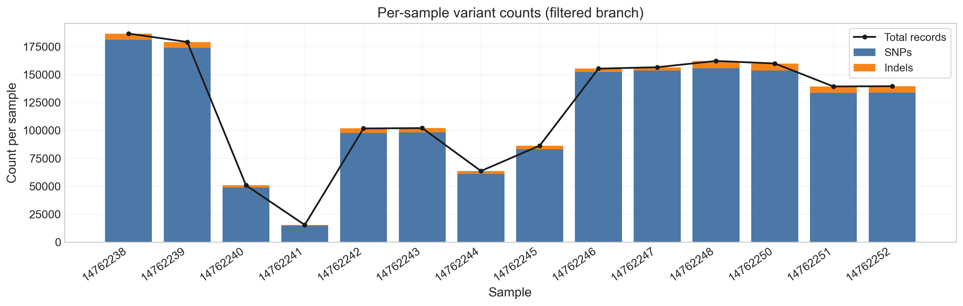

Figure 1. Per-sample filtered variant counts (GATK-filtered branch). Y-axis: total PASS variant records; X-axis: SRA run identifiers. Colors distinguish condition labels (wound edge vs. unwounded skin).

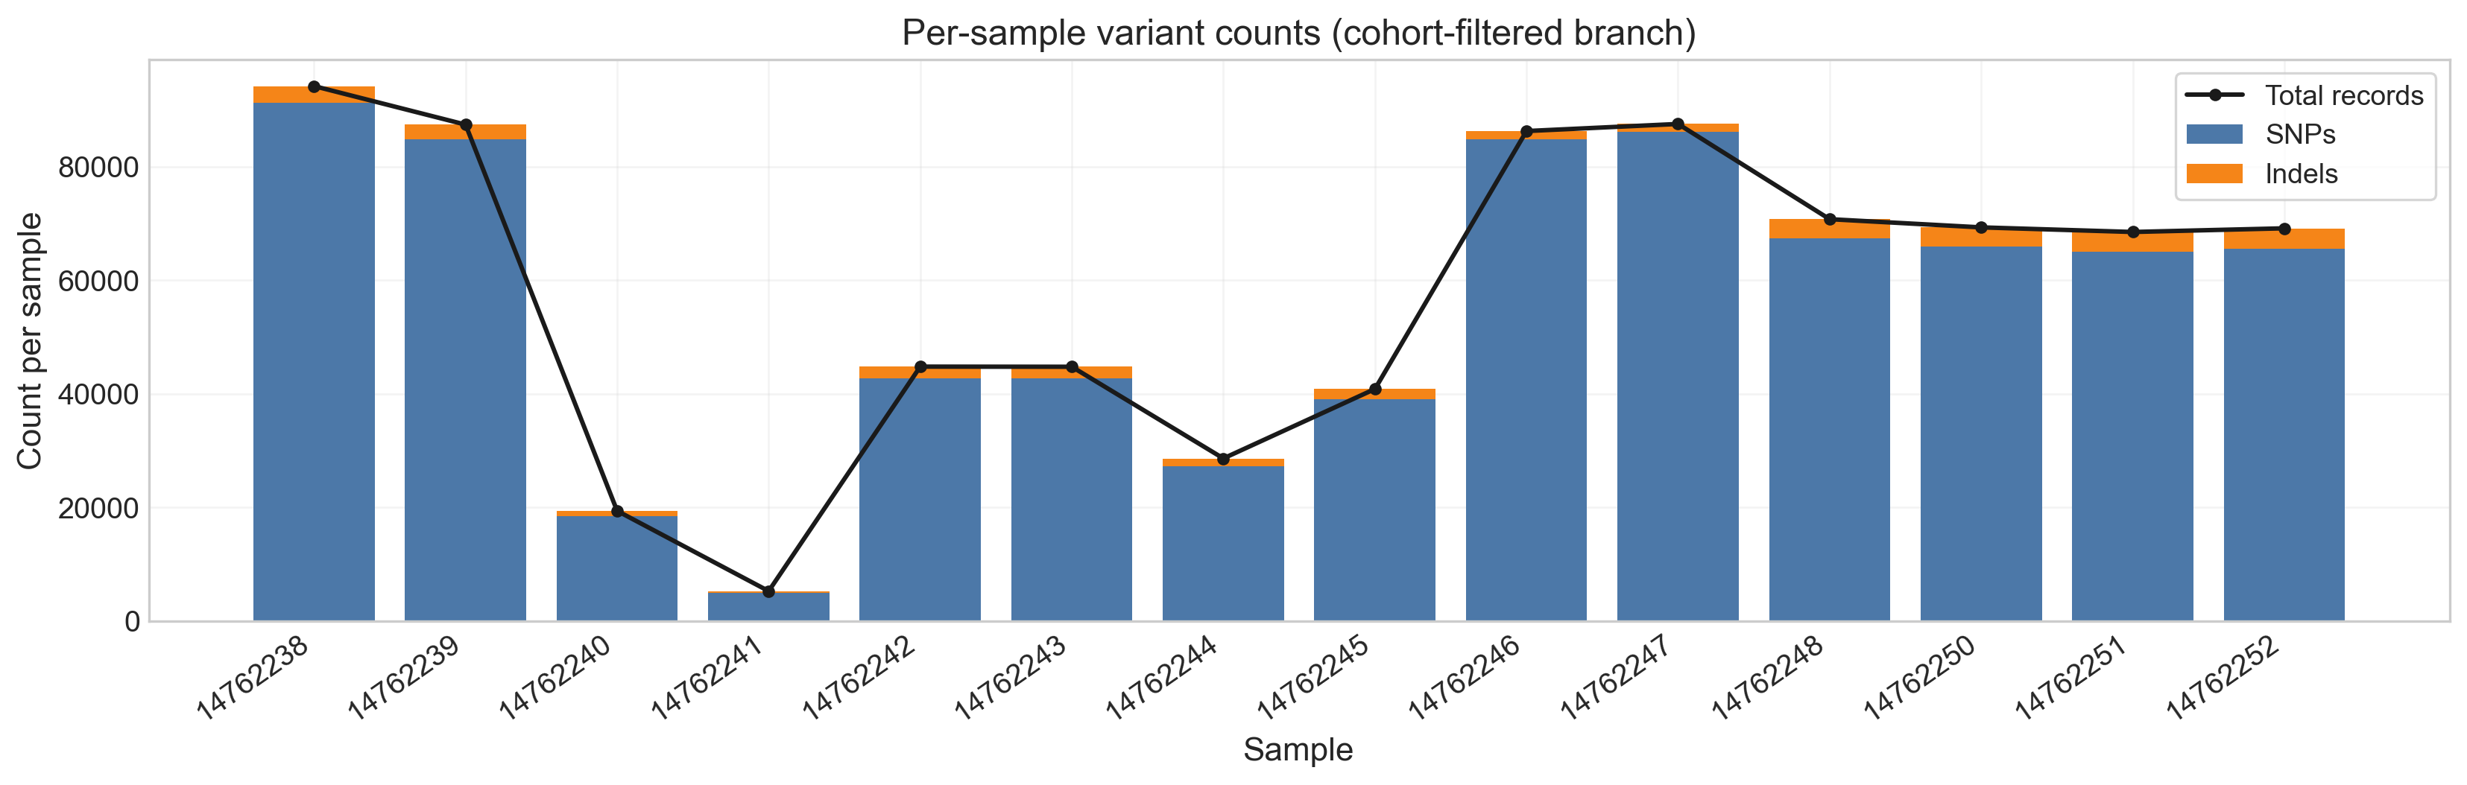
Figure 2. Per-sample cohort-filtered variant counts. Note the proportional downward shift relative to Figure 1 while inter-sample rank ordering is largely preserved, confirming cohort-frequency filtering removes shared signal without wholesale reordering of the burden landscape.

3.3. Caller Comparison: BCFtools vs. GATK
Table S1 (Supplementary) provides a direct numerical comparison between the historical BCFtools baseline and the active GATK workflow. At cohort level, GATK produced a 7.09× higher median filtered record count (989,201 vs. 139,422), 35.2% more genes with non-zero burden (27,902 vs. 20,634), and a 24.2× higher aggregate mutation burden total (41,059,802 vs. 1,698,411). Critically, the top-20 mutated gene lists from the two callers shared no overlap (0 of 20 genes), confirming that caller choice has a profound effect on the mutation-derived gene sets used in downstream enrichment and ML analyses.

Table S1. Caller comparison: BCFtools (historical baseline) vs. GATK (active workflow).
Metric | BCFtools (Baseline) | GATK (Active) | Δ (Abs) | Ratio | Direction
Filtered records median | 139,422 | 989,201 | +849,779 | 7.09× | GATK↑
Genes with variant burden | 20,634 | 27,902 | +7,268 | 1.35× | GATK↑
Mutation burden total | 1,698,411 | 41,059,802 | +39,361,391 | 24.17× | GATK↑
Top-20 gene overlap (callers) | 20/20 | 0/20 | −20 | 0.00× | No overlap

These differences underscore the importance of declaring the variant caller and its parameterization as first-class methodological choices in any scRNA-seq mutation-based ML study. The BCFtools and GATK pipelines are not interchangeable; their variant detection strategies, sensitivity-specificity tradeoffs, and artifact profiles differ substantially in the RNA-seq context.

3.4. Classification Performance and Permutation Testing
Table 3 summarizes primary ML outcomes for both feature branches. Feature dimension decreased from 20,634 (filtered) to 18,860 (cohort-filtered), an 8.60% reduction. Best repeated-CV balanced accuracy improved from 0.9733 to 0.9800 (+0.67 pp), with linear SVC selected as the optimal model in both branches. Permutation p-values were 0.00995 (filtered) and 0.01493 (cohort-filtered), both well below α = 0.05, indicating statistically significant classification above chance under the run-level protocol.

Table 3. Primary ML summary by feature branch.
Feature Branch | n | Features | Best Bal. Acc. | Permutation p | Best CV Model | Repeats | Perms.
Filtered | 14 | 20,634 | 0.9733 | 0.00995 | Linear SVC | 30 | 200
Cohort-filtered | 14 | 18,860 | 0.9800 | 0.01493 | Linear SVC | 30 | 200

Given 200 permutations, a p-value of 0.00995 corresponds to approximately 1 permuted score exceeding the observed score, representing a near-minimal discrete tail count. This result should be interpreted conservatively: the small sample size (n = 14) limits the precision of permutation null distributions and precludes strong probabilistic guarantees. Nevertheless, the consistency of significance across both branches, combined with the large performance gap relative to chance (balanced accuracy ~0.97–0.98 vs. expected 0.50), provides reasonable evidence of non-random signal in the run-level data.
Table 4 details model-family comparisons. Linear SVC and L2 logistic regression achieved the highest balanced accuracy means (0.9800 and 0.9700, respectively), with comparable ROC AUC (0.9933 and 0.9867). Random forest, despite achieving the highest ROC AUC mean (0.9950), produced materially lower balanced accuracy (0.8033), indicating weaker thresholded class-balance behavior in this small-n, imbalanced setting. L1 logistic regression underperformed markedly (balanced accuracy 0.7967), consistent with sparse regularization introducing excessive feature elimination in a high-dimensional, low-sample regime.
The distribution of balanced accuracy across model families is shown in Figure 3, where Linear SVC and L2-regularized logistic regression dominate. Random forest exhibits higher variance, likely due to the limited effective sample size. Similar performance patterns are observed in the cohort-filtered feature branch, as illustrated in Figure 4, confirming that feature-branch choice does not materially affect model selection conclusions.

Table 4. Repeated-CV model comparison (cohort-filtered branch).
Model | Bal. Acc. Mean | Bal. Acc. Std | ROC AUC Mean | Branch
Linear SVC | 0.9800 | 0.0980 | 0.9933 | Cohort-filt.
Logistic Reg. L2 | 0.9700 | 0.1187 | 0.9867 | Both
LogReg PCA-10 | 0.9700 | 0.1187 | 0.9867 | Cohort-filt.
LogReg k-Best | 0.8950 | 0.1899 | 0.9833 | Cohort-filt.
Random Forest (500) | 0.8033 | 0.2320 | 0.9950 | Cohort-filt.
LogReg L1 | 0.7967 | 0.2387 | 0.9033 | Cohort-filt.

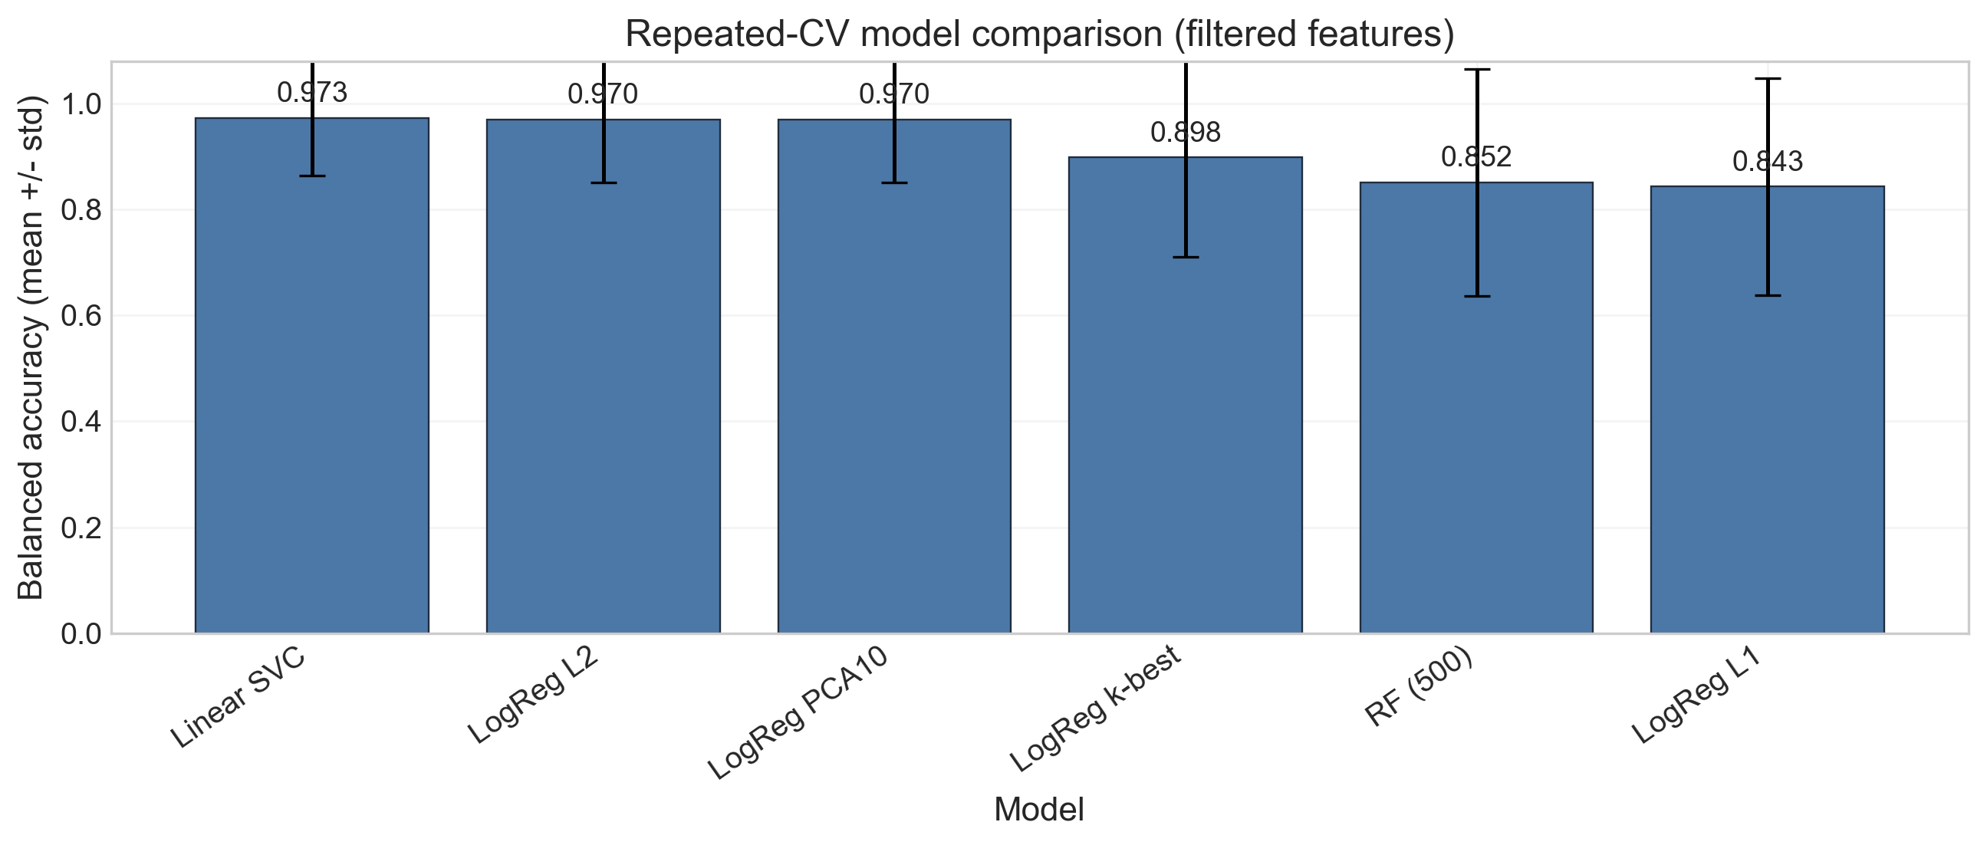
Figure 3. Repeated-CV balanced accuracy distributions across model families (filtered feature branch). Linear SVC and L2-regularized logistic regression dominate; random forest shows high variance due to small effective sample size.

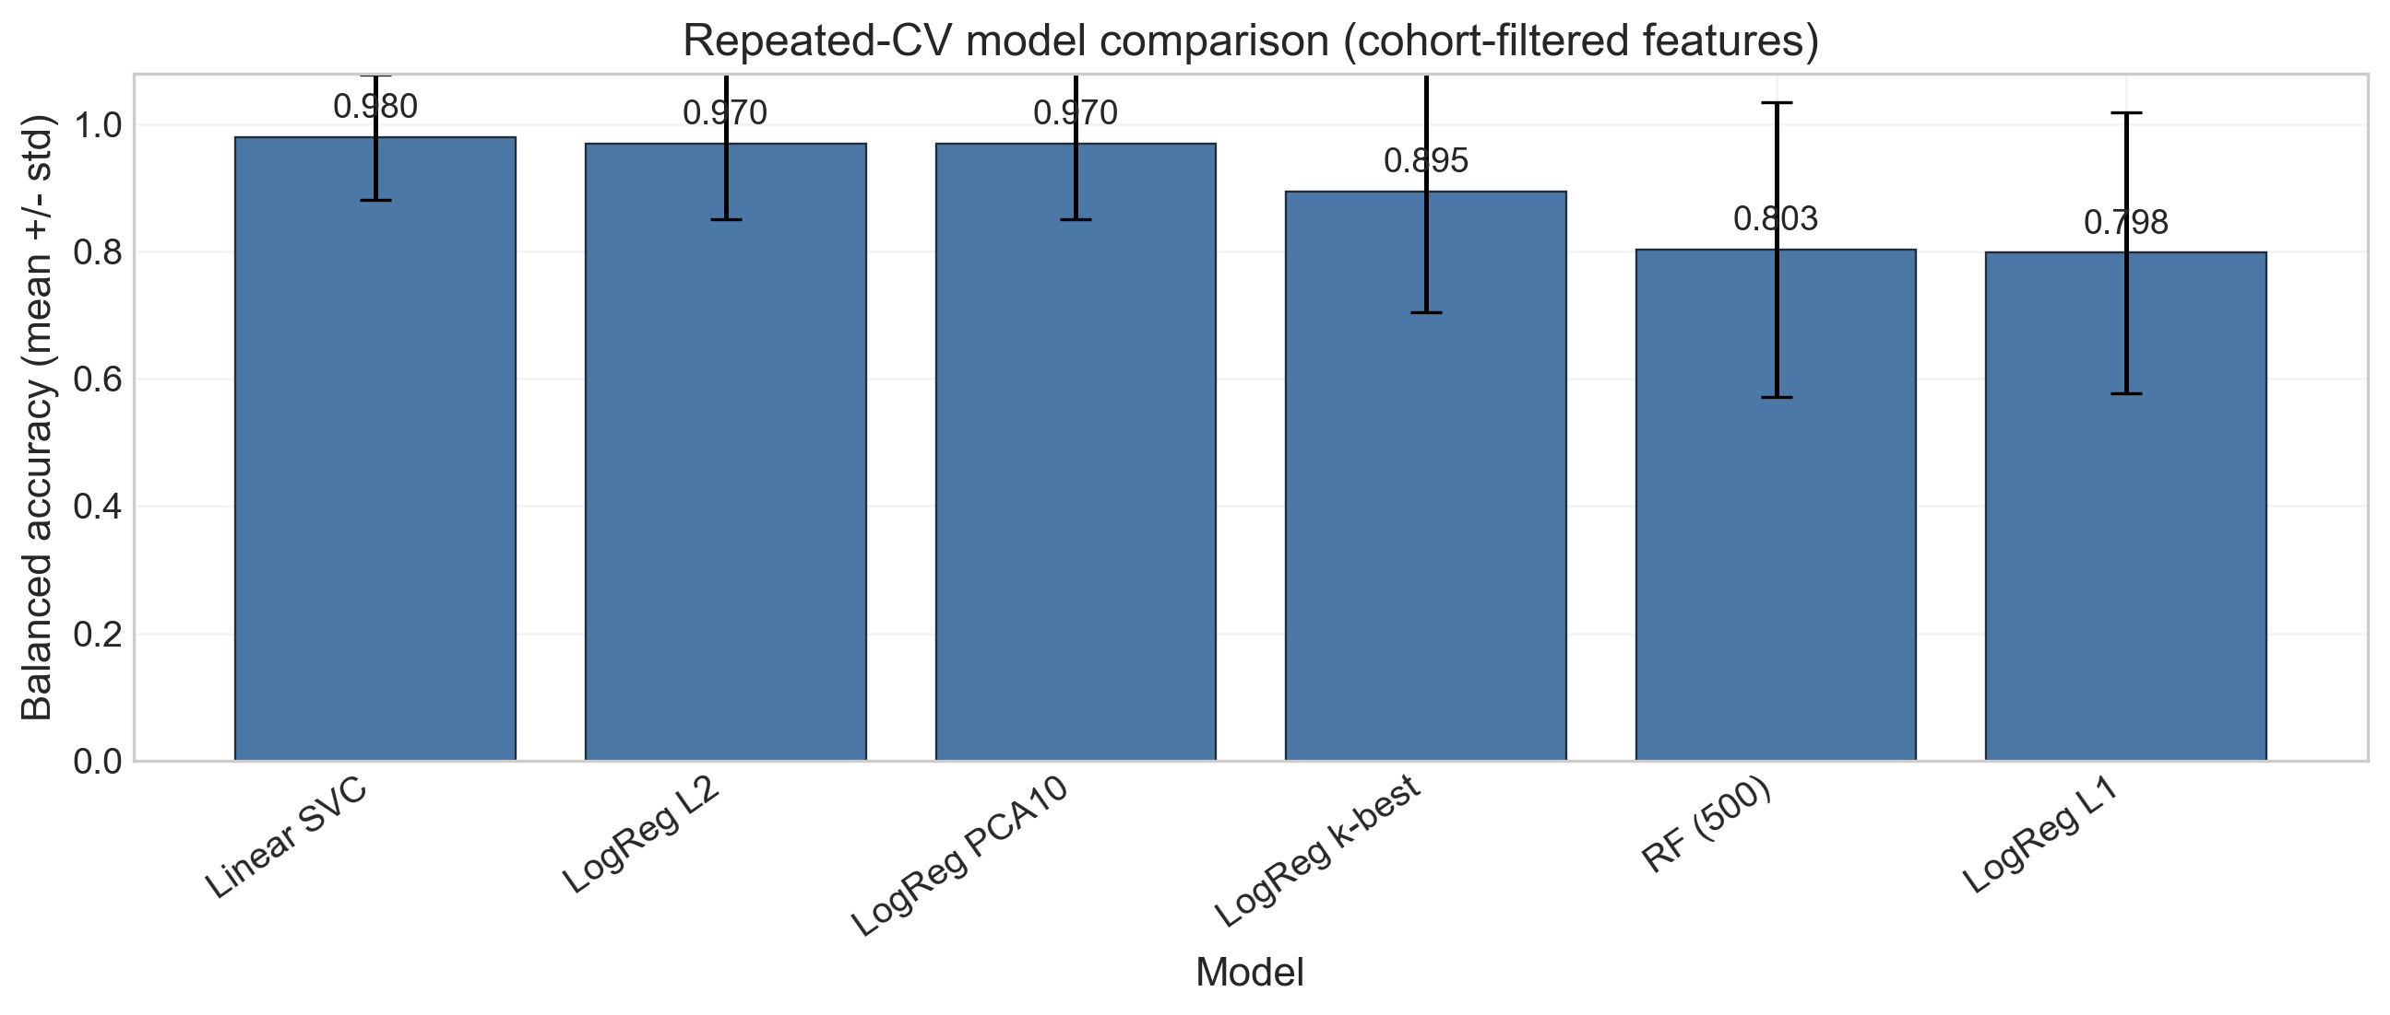
Figure 4. Repeated-CV balanced accuracy distributions (cohort-filtered feature branch). Performance ordering is stable relative to Figure 3, confirming that feature-branch choice does not materially alter model selection conclusions.

3.5. Split-Sensitivity and Leakage Analysis
Table 5 presents the most consequential finding of this study. Under run-level repeated stratified CV, the best model achieved a mean balanced accuracy of 0.9633. Under donor-grouped 7-fold evaluation—which enforces strict leave-one-donor-out separation—this figure collapsed to 0.3571, corresponding to an absolute drop of 0.6062 (relative drop 62.9%). Accuracy followed the same pattern (0.9511 → 0.3571).

Table 5. Split-sensitivity comparison: run-level vs. donor-grouped evaluation. Additional leakage-sensitivity metrics are provided in Table S4.
Evaluation Protocol | n Runs | n Donors | Accuracy Mean | Bal. Acc. Mean
Run-level repeated stratified CV (5-fold × 30) | 14 | 7 | 0.9511 | 0.9633
Donor-grouped KFold (7-fold) | 14 | 7 | 0.3571 | 0.3571
Absolute drop (Δ balanced accuracy) | - | - | - | 0.606 (−62.9%)

A balanced accuracy of 0.357 in the donor-grouped setting is below the random chance baseline (0.50), indicating that the classifier trained on within-donor run data does not generalize meaningfully across donor boundaries. This result is consistent with the PCA structure observed in Figures 6 and 7, where within-donor run pairs cluster far more tightly than between-donor centroids.
PCA analysis, as shown in Figures 5 and 6, quantified this structure explicitly. An additional cluster-aggregation view of the mutation signal used for downstream integration is provided in Figure S1. For filtered features, the median within-donor Euclidean distance was 3.85, versus a median between-donor centroid distance of 124.76 (ratio 0.031). For cohort-filtered features, these values were 3.11 and 86.45 (ratio 0.036). The largest within-donor separation was observed for donor D02 (filtered: 25.05 distance units) and donor D01 (cohort-filtered: 39.94), indicating that while all within-donor pairs cluster tightly relative to between-donor distances, individual donor pairs vary in their run-level consistency.
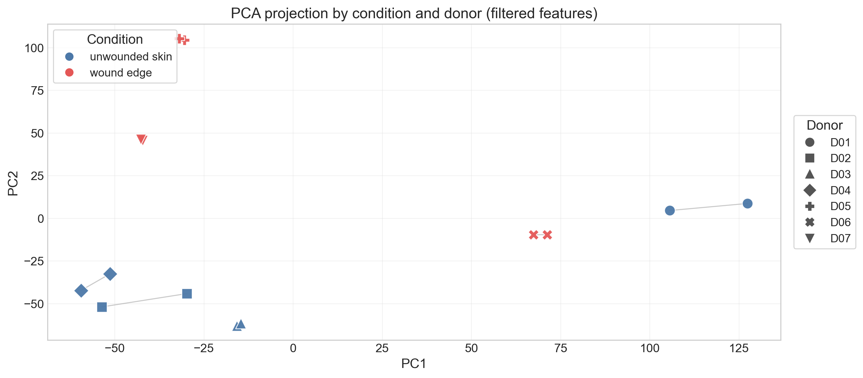
Figure 5. PCA projection of all 14 runs (filtered features), with class label and donor proxy overlays. Within-donor run pairs (connected by lines) cluster closely; between-donor centroids are widely separated. Median within-donor distance: 3.85; median between-donor centroid distance: 124.76 (ratio 0.031).
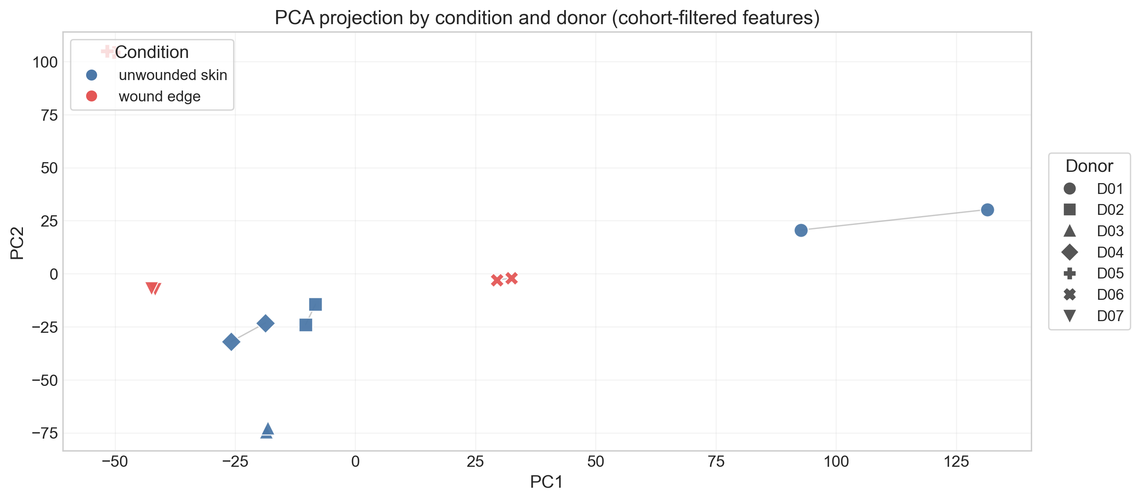
Figure 6. PCA projection (cohort-filtered features). The within-donor clustering structure is preserved and quantitatively similar to Figure 5 (ratio 0.036), confirming that cohort-frequency filtering does not meaningfully alter the donor-structured geometry of feature space.
The mechanistic interpretation of this finding is straightforward: the gene-burden feature vectors encode substantial within-donor technical consistency (shared sequencing batch, library prep, and alignment conditions for paired runs), which naive CV exploits as a discriminative signal but which is absent in a true out-of-donor test scenario. Without explicit donor-aware split design, this structure produces an optimistic performance illusion.

3.6. Expression–Mutation Correlation Analysis
Table 6 presents the Spearman correlation matrix among three run-level burden metrics. Total gene burden was positively associated with both filtered records (ρ = 0.684) and cohort-filtered records (ρ = 0.837). The strongest pairwise association was between filtered and cohort-filtered record counts (ρ = 0.947), confirming that cohort filtering preserves the relative burden structure across samples rather than introducing substantial reordering. These correlations indicate that samples with high total variant burden tend to retain proportionally more records after cohort filtering, suggesting that within-donor technical variation, rather than systematic cohort-common locus removal, drives count variability.

Table 6. Spearman correlation matrix (run-level mutational burden metrics). Related visualizations are provided in Figures S2 and S3.
Metric | Total Gene Burden | Filtered Records | Cohort-filt. Records
Total gene burden | 1.000 | 0.684 | 0.837
Filtered records | 0.684 | 1.000 | 0.947
Cohort-filtered records | 0.837 | 0.947 | 1.000

Hypergeometric marker-overlap enrichment testing comprised 114 tests (38 clusters × 3 mutation-derived gene sets). Of these, only 13 tests yielded any overlap (overlap_n > 0), and only 1 test reached nominal significance (p < 0.05): cluster 8 (T cell) against wound_edge_higher_mutation_burden, with the single overlap gene IL7R (p = 0.042, q = 0.631). No test survived FDR correction (q < 0.05: 0 tests). See Figure S4 for overlap heatmap visualization, Figure S5 for enrichment heatmap visualization, and Tables S5-S7 for full overlap, enrichment, and expression-marker reference tables.
The sparsity and non-significance of marker-mutation overlaps is consistent with the expectation that somatic-like expressed variants detected through scRNA-seq variant calling are not systematically co-localized with transcriptional cluster markers. Expressed variants capture a different biological layer (somatic mosaicism, RNA editing, alignment artifacts, or low-frequency germline variation) than the differentially expressed genes that define transcriptional clusters. The absence of significant overlap after FDR correction should not be interpreted as a negative biological finding but rather as confirmation that these two feature types are largely orthogonal.

3.7. Functional Enrichment Context
Table 7 summarizes top enrichment terms for three mutation-derived gene sets, included as contextual annotation rather than causal biological claims. The top_mutated_genes set was enriched for broad cellular compartment terms (cytoplasm, cytosol) and general molecular function terms (ion binding, small molecule binding), reflecting the broad genomic distribution of expressed variants rather than a specific biological program.

Table 7. Top enrichment terms by mutation-derived gene set (g:Profiler).
Gene Set | Term | Source | ID | p-value
top_mutated_genes | Cytoplasm | GO:CC | GO:0005737 | 1.47 × 10⁻⁶
top_mutated_genes | Ion binding | GO:MF | GO:0043167 | 8.53 × 10⁻⁶
wound_edge_higher | MHC protein complex | GO:CC | GO:0042611 | 7.69 × 10⁻⁸
wound_edge_higher | Allograft rejection | KEGG | KEGG:05330 | 2.35 × 10⁻⁶
unwounded_skin_higher | Scavenger receptor binding | REAC | REAC:R-HSA-2173782 | 4.90 × 10⁻¹²
unwounded_skin_higher | FCGR activation | REAC | REAC:R-HSA-2029481 | 1.49 × 10⁻¹¹

The wound_edge_higher_mutation_burden set showed enrichment for immune-associated categories including MHC protein complex (GO:0042611; p = 7.69 × 10⁻⁸), allograft rejection (KEGG:05330; p = 2.35 × 10⁻⁶), and antigen binding (GO:0003823; p = 4.02 × 10⁻⁷). These terms are biologically plausible in the wound context, where immune activation and antigen presentation are expected, but they do not constitute evidence of direct mechanistic involvement of the variant-harboring genes.
The unwounded_skin_higher_mutation_burden set showed enrichment for scavenger receptor binding (REAC:R-HSA-2173782; p = 4.90 × 10⁻¹²), FCGR activation (REAC:R-HSA-2029481; p = 1.49 × 10⁻¹¹), and immunoglobulin complex (GO:0019814; p = 2.29 × 10⁻¹¹). The prominence of phagocytosis-related and Fc-receptor-associated pathways in unwounded skin may reflect baseline immune surveillance activity in resting skin tissue, as summarized in Figure 7.

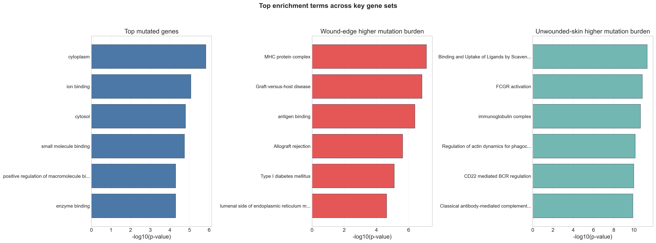
Figure 7. Summary of top enrichment terms by mutation-derived gene set. This figure should be interpreted as contextual annotation; enrichment p-values reflect the overall mutated gene-set composition and are not evidence of condition-specific functional activation. Gene-set-specific enrichment panels are provided in Figures S6-S8.

4. Discussion

4.1. The Split-Sensitivity Gap as a Core Finding

The central technical finding of this study—a 62.9% relative collapse in balanced accuracy when moving from run-level to donor-grouped evaluation—has direct implications for the interpretation of biomedical ML studies using sequencing data from small cohorts with within-sample replication structure. A performance figure of 0.96 balanced accuracy reported without donor-grouped verification would be grossly misleading in this context: the true out-of-donor performance is effectively at chance (0.357, below the 0.50 random baseline).

This phenomenon is not unique to variant-derived features. Similar gaps have been observed in RNA-seq differential expression classifiers, imaging-based models, and single-cell embedding methods when sample-level leakage is present [13,14,23,15]. A cross-field analysis of data leakage documented systematic overoptimistic performance across 294 studies [15], and nested cross-validation frameworks specifically designed for high-dimensional biomedical data have been proposed to address this problem [6]. What distinguishes this study is the explicit, quantified reporting of both bounds: the optimistic run-level estimate and the conservative donor-level estimate, with transparent attribution of the gap to within-donor technical similarity rather than to model failure.

From a methodological perspective, the PCA visualizations (Figures 6 and 7) provide an accessible, intuitive explanation of the split-sensitivity gap. The ratio of within-donor to between-donor distances (0.031–0.036) indicates that paired runs from the same donor are nearly indistinguishable in feature space compared to the separations between donors. Under run-level CV, the model effectively learns donor-specific patterns rather than condition-specific biology, yielding high within-distribution but near-zero out-of-distribution performance.

4.2. Cohort-Frequency Filtering: Efficiency vs. Information

Cohort-frequency filtering reduced feature dimensionality by 8.60% (20,634 → 18,860 genes) while maintaining stable or marginally improved balanced accuracy (+0.67 pp). This result suggests that cohort-common loci, by definition observed at high frequency across all samples, provide little condition-discriminative information and can be safely removed without performance cost. The stability of the filtered and cohort-filtered Spearman correlation structure (ρ = 0.947 between record counts) confirms that the relative burden ordering across samples is preserved after filtering.

However, the practical significance of an 8.60% feature reduction is modest in this dataset, where n = 14 samples renders any high-dimensional feature matrix effectively underspecified. A more aggressive filtering strategy—for example, requiring variant presence in at most 25% of samples rather than 4 of 14 (28.6%)—might yield greater dimensionality reduction, at the cost of potentially removing biologically relevant polymorphisms. Future work should systematically explore cohort-frequency threshold sensitivity as a hyperparameter of the feature engineering pipeline.

4.3. Caller Choice as a Methodological Confound

Variant calling from scRNA-seq data enables the linkage of somatic mutational states to transcriptional phenotypes at cellular resolution [24]. Benchmarking studies have shown that bulk callers applied to pooled single-cell reads, including GATK HaplotypeCaller, significantly outperform individual-cell approaches in terms of precision-recall tradeoff in scRNA-seq and scATAC-seq libraries [25]. These findings motivated our use of GATK on pooled-read BAMs rather than cell-level calling, which would be infeasible given the expected read depth per cell in the 10x Chromium protocol.

This finding reinforces the broader argument for full pipeline transparency: it is insufficient to state that variants were called using GATK or BCFtools without specifying filter labels, quality thresholds, mode of operation (GVCF vs. single-sample), and post-calling processing steps. The present study addresses this by taking all parameter values directly from project configuration files, which are publicly available in the linked GitHub repository.

4.4. Model Selection and the ROC AUC vs. Balanced Accuracy Discrepancy

The divergence between random forest ROC AUC (0.9950) and balanced accuracy (0.8033) illustrates a frequently misunderstood aspect of classifier evaluation in class-imbalanced settings. ROC AUC measures rank discrimination over all decision thresholds, and can remain high even when no single threshold simultaneously maximizes sensitivity and specificity. Balanced accuracy, in contrast, evaluates performance at the default decision threshold and explicitly accounts for class imbalance by averaging class-conditional accuracies.

In the present dataset (8 vs. 6 samples), the ensemble randomness of random forest (500 trees) combined with small effective sample size produces high variance in balanced accuracy (std = 0.232), making it unreliable as a production classifier despite strong AUC. Linear SVC and L2 logistic regression, by contrast, produce lower variance estimates (std = 0.098 and 0.119, respectively) and higher mean balanced accuracy, making them preferable for this application profile. This model selection rationale—prioritizing stability and balanced accuracy over AUC in small-n, class-imbalanced settings—should be stated explicitly in any comparative ML study.

4.5. Expression–Mutation Orthogonality and Interpretation Constraints

The near-complete absence of significant marker-to-mutation overlaps (0/114 tests surviving FDR correction; minimum q = 0.631) is conceptually expected and informative. Expression-based cluster markers identify genes whose transcriptional levels differentiate cell populations within the single-cell atlas; mutation-derived gene burden identifies genes that harbor expressed variants at elevated rates. These two quantities capture different aspects of gene biology and need not co-localize.

A systematic absence of overlap rules out the simplest hypothesis—that the genes driving transcriptional cluster identity are the same genes accumulating expressed variants—without implying any relationship between the broader mutational and transcriptional landscapes. The Spearman correlations between burden metrics (ρ = 0.684–0.947) confirm internal consistency within the mutational feature branch, but this consistency exists at the whole-sample level and does not constrain gene-level overlaps with cluster-specific markers.

This interpretation framework – explicitly distinguishing what the data can and cannot support—represents a key element of the reproducibility-first philosophy underlying this study. Overly broad biological claims from small-cohort, single-dataset ML studies without independent replication are a recognized problem in biomedical informatics [26], and the present work deliberately constrains its interpretive scope to what the analytical evidence directly supports. Formal reproducibility standards for ML in the life sciences have recently codified exactly these requirements—transparent pipeline documentation, split-aware validation, and conservative interpretation—as minimum quality criteria [27,29].

4.6. Limitations

Several limitations of this study must be acknowledged. First, the donor count (n = 7) is insufficient for robust leave-one-donor-out evaluation: each fold in donor-grouped CV uses only one donor for testing, making performance estimates highly sensitive to individual donor outlier effects. Future studies should target a minimum of 20–30 independent donors to achieve stable donor-grouped performance estimates.

Second, the absence of an external independent cohort precludes assessment of out-of-distribution generalization beyond the study dataset. The donor-grouped performance figure (balanced accuracy 0.357) is a conservative internal bound, not a true generalization estimate.

Third, the variant features used here are derived from bulk alignment of single-cell reads without cell-type-specific variant calling. Future work could leverage cell-type-demultiplexed BAMs to perform cell-type-resolved variant analysis, potentially revealing condition-specific variant enrichment in particular cell populations (e.g., fibroblasts, keratinocytes, immune cells) that is obscured in sample-level aggregation.

Fourth, the run-pair structure (two runs per donor) introduces potential confounding between technical replication and biological variation. While this structure motivates the donor-grouped evaluation strategy, it also limits the interpretability of between-donor differences without additional metadata on sample collection and processing conditions.

5. Conclusions
This study presents a reproducibility-first ML framework for scRNA-seq variant-derived classification, with explicit quantification of split sensitivity, dual-branch feature engineering, caller comparison, and expression–mutation correlation. The primary technical finding is the pronounced gap between run-level (balanced accuracy 0.963) and donor-grouped (0.357) evaluation—a 62.9% relative performance collapse that would be entirely invisible without explicit donor-aware validation design.
The practical conclusions are unambiguous: in small-cohort scRNA-seq studies with within-donor run replication, run-level repeated stratified CV produces optimistic performance estimates that do not reflect out-of-donor generalizability. Donor-grouped evaluation and explicit split-sensitivity reporting are essential, not optional, components of credible biomedical ML workflows, consistent with recently proposed reproducibility standards for ML in the life sciences [27,29]. Cohort-frequency filtering provides modest but consistent dimensionality reduction without performance penalty. Caller choice exerts a first-order effect on mutation-derived feature sets and must be reported in full reproducible detail.
This pipeline, its parameterization, and all result tables are publicly available, enabling independent replication and extension to larger multi-cohort wound healing datasets. The framework is directly transferable to other scRNA-seq classification problems where within-donor run replication creates implicit validation challenges.
Supplementary Materials: Processed tables and figures are available in the project repository under Final version/results/. Supplementary Figures S1-S8 are bundled in manuscript_q1_supplementary/supplementary_figures/, and Supplementary Tables S1-S8 are bundled in manuscript_q1_supplementary/supplementary_tables/. Code and full analysis workflows are publicly available at https://github.com/dauletulyaidyn/somatic-like-scrna-variants-ml-pipeline (accessed 22 February 2026). Additional per-sample reduction statistics and full model hyperparameter configurations are available in the repository.
Pipeline Overview: The complete RNA-seq variant-calling pipeline is shown in Figure 8, highlighting preprocessing, variant calling using GATK HaplotypeCaller, and subsequent filtering steps.
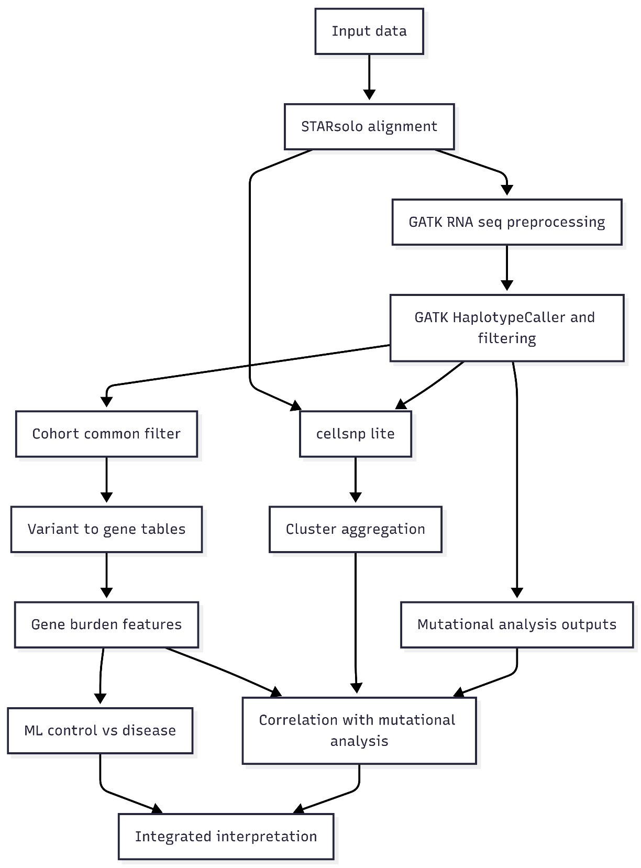

Figure 8. End-to-end workflow integrating STARsolo-based expression analysis, GATK-based mutational analysis, downstream machine-learning classification, and expression–mutation correlation analysis.
Author Contributions: Conceptualization, A.K.; Methodology, A.K., A.S.; Software, A.K.; Validation, B.O.; Formal Analysis, A.K.; Investigation, A.S.; Data Curation, A.K., A.S.; Writing – Original Draft Preparation, A.K., A.Y.; Writing – Review & Editing, A.K., A.Y., B.O.; Visualization, A.K.; Supervision, A.Y., B.O. The author has read and agreed to the published version of the manuscript.
Funding: This research was funded by the Science Committee of the Ministry of Education and Science of the Republic of Kazakhstan (Grant No. AP22686112 Study of somatic mutations from single-cell RNA data using machine learning methods in patients with peripheral artery disease).
Institutional Review Board Statement: Not applicable. This study used publicly available, de-identified sequencing data (BioProject PRJNA736095) and did not involve human subjects research requiring IRB oversight.
Informed Consent Statement: Not applicable.
Data Availability Statement: The original sequencing data are openly available in NCBI BioProject PRJNA736095 (https://www.ncbi.nlm.nih.gov/bioproject/PRJNA736095). Run-level metadata are available at Final version/results/tables/table0_external_metadata_geosra.csv. All derived result tables, figures, and analysis code are available at https://github.com/dauletulyaidyn/somatic-like-scrna-variants-ml-pipeline (accessed 22 February 2026).
Acknowledgments: The authors acknowledges public data providers (NCBI SRA/GEO) and the original PRJNA736095 study contributors. During the preparation of this manuscript, the author used a generative AI assistant for drafting and structural editing support. The authors would like to thank Anar Sultangaziyeva for her insightful comments and support throughout this project.
Conflicts of Interest: The authors declares no conflicts of interest.

References
- Dobin, A.; Davis, C.A.; Schlesinger, F.; Drenkow, J.; Zaleski, C.; Jha, S.; Batut, P.; Chaisson, M.; Gingeras, T.R. STAR: ultrafast universal RNA-seq aligner. Bioinformatics 2013, 29, 15–21. https://doi.org/10.1093/bioinformatics/bts635
- Li, H.; Handsaker, B.; Wysoker, A.; Fennell, T.; Ruan, J.; Homer, N.; Marth, G.; Abecasis, G.; Durbin, R. The Sequence Alignment/Map format and SAMtools. Bioinformatics 2009, 25, 2078–2079. https://doi.org/10.1093/bioinformatics/btp352
- Danecek, P.; Bonfield, J.K.; Liddle, J.; Marshall, J.; Ohan, V.; Pollard, M.O.; Whitwham, A.; Keane, T.; McCarthy, S.A.; Davies, R.M.; et al. Twelve years of SAMtools and BCFtools. GigaScience 2021, 10, giab008. https://doi.org/10.1093/gigascience/giab008
- Pedregosa, F.; Varoquaux, G.; Gramfort, A.; Michel, V.; Thirion, B.; Grisel, O.; Blondel, M.; Prettenhofer, P.; Weiss, R.; Dubourg, V.; et al. Scikit-learn: Machine Learning in Python. J. Mach. Learn. Res. 2011, 12, 2825–2830
- Whalen, S.; Schreiber, J.; Noble, W.S.; Pollard, K.S. Navigating the pitfalls of applying machine learning in genomics. Nat. Rev. Genet. 2022, 23, 169–181. https://doi.org/10.1038/s41576-021-00434-9
- Lewis, M.J.; Spiliopoulou, A.; Goldmann, K.; Pitzalis, C.; McKeigue, P.; Barnes, M.R. nestedcv: an R package for fast implementation of nested cross-validation with embedded feature selection designed for transcriptomics and high-dimensional data. Bioinform. Adv. 2023, 3, vbad048. https://doi.org/10.1093/bioadv/vbad048
- Liu, Z.; Bian, X.; Luo, L.; Björklund, Å.K.; Li, L.; Zhang, L.; Chen, Y.; Guo, L.; Gao, J.; Cao, C.; Wang, J.; He, W.; Xiao, Y.; Zhu, L.; Annusver, K.; Gopee, N.H.; Basurto-Lozada, D.; Horsfall, D.; Bennett, C.L.; Kasper, M.; Haniffa, M.; Sommar, P.; Li, D.; Landén, N.X. Spatiotemporal single-cell roadmap of human skin wound healing. Cell Stem Cell 2025, 32, 479–498.e8. https://doi.org/10.1016/j.stem.2024.11.013
- Guerrero-Juarez, C.F.; Dedhia, P.H.; Jin, S.; Ruiz-Vega, R.; Ma, D.; Liu, Y.; Yamaga, K.; Shestova, O.; Gay, D.L.; Yang, Z.; et al. Single-cell analysis reveals fibroblast heterogeneity and myeloid-derived adipocyte progenitors in murine skin wounds. Nat. Commun. 2019, 10, 650. https://doi.org/10.1038/s41467-018-08247-x
- Chen, C.-J.; Kajita, H.; Takaya, K.; Aramaki-Hattori, N.; Sakai, S.; Asou, T.; Kishi, K. Single-cell RNA-seq analysis reveals cellular functional heterogeneity in dermis between fibrotic and regenerative wound healing fates. Front. Immunol. 2022, 13, 875407. https://doi.org/10.3389/fimmu.2022.875407
- Ojala, M.; Garriga, G.C. Permutation tests for studying classifier performance. J. Mach. Learn. Res. 2010, 11, 1833–1863
- Raudvere, U.; Kolberg, L.; Kuzmin, I.; Arak, T.; Adler, P.; Peterson, H.; Vilo, J. g:Profiler: a web server for functional enrichment analysis and conversions of gene lists (2019 update). Nucleic Acids Res. 2019, 47, W191–W198. https://doi.org/10.1093/nar/gkz369
- National Center for Biotechnology Information. BioProject PRJNA736095. Available online: https://www.ncbi.nlm.nih.gov/bioproject/PRJNA736095 (accessed on 22 February 2026)
- Wainer, J.; Cawley, G. Nested cross-validation when selecting classifiers is overzealous for most practical applications. Expert Syst. Appl. 2021, 182, 115222. https://doi.org/10.1016/j.eswa.2021.115222
- Varoquaux, G.; Raamana, P.R.; Engemann, D.A.; Hoyos-Idrobo, A.; Schwartz, Y.; Thirion, B. Assessing and tuning brain decoders: cross-validation, caveats, and guidelines. NeuroImage 2017, 145, 166–179. https://doi.org/10.1016/j.neuroimage.2016.10.038
- Kapoor, S.; Narayanan, A. Leakage and the reproducibility crisis in machine-learning-based science. Patterns 2023, 4, 100804. https://doi.org/10.1016/j.patter.2023.100804
- McKenna, A.; Hanna, M.; Banks, E.; Sivachenko, A.; Cibulskis, K.; Kernytsky, A.; Garimella, K.; Altshuler, D.; Gabriel, S.; Daly, M.; et al. The Genome Analysis Toolkit: A MapReduce framework for analyzing next-generation DNA sequencing data. Genome Res. 2010, 20, 1297–1303. https://doi.org/10.1101/gr.107524.110
- Brouard, J.S.; Bissonnette, N. Variant Calling from RNA-seq Data Using the GATK Joint Genotyping Workflow. Methods Mol. Biol. 2022, 2493, 205–233. https://doi.org/10.1007/978-1-0716-2293-3_13
- Okonechnikov, K.; et al. Best practices for variant calling in clinical sequencing. Genome Med. 2020, 12, 100. https://doi.org/10.1186/s13073-020-00791-w
- Spearman, C. The proof and measurement of association between two things. Am. J. Psychol. 1904, 15, 72–101. https://doi.org/10.2307/1412159
- Benjamini, Y.; Hochberg, Y. Controlling the false discovery rate: a practical and powerful approach to multiple testing. J. R. Stat. Soc. B 1995, 57, 289–300. https://doi.org/10.1111/j.2517-6161.1995.tb02031.x
- Lefouili, M.; Nam, K. The evaluation of BCFtools mpileup and GATK HaplotypeCaller for variant calling in non-human species. Sci. Rep. 2022, 12, 11331. https://doi.org/10.1038/s41598-022-15563-2
- Deshpande, N.P.; et al. Benchmarking of individual somatic variant callers and voting-based ensembles for whole-exome sequencing. Brief. Bioinform. 2023, 26, bbae697. https://doi.org/10.1093/bib/bbae697
- Luo, Y.; Hitz, B.C.; Gabdank, I.; Hilton, J.A.; Kagda, M.S.; Lam, B.; Myers, Z.; Sud, P.; Jou, J.; Lin, K.; et al. New developments on the Encyclopedia of DNA Elements (ENCODE) data portal. Nucleic Acids Res. 2020, 48, D882–D889. https://doi.org/10.1093/nar/gkz1062
- Ramazzotti, D.; Angaroni, F.; Maspero, D.; et al. Variant calling from scRNA-seq data allows the assessment of cellular identity in patient-derived cell lines. Nat. Commun. 2022, 13, 2718. https://doi.org/10.1038/s41467-022-30230-0
- Wiens, M.; Farahani, H.; Scott, R.W.; Underhill, T.M.; Bashashati, A. Benchmarking bulk and single-cell variant-calling strategies in scRNA-seq and scATAC-seq. Genome Res. 2024, 34, 1196–1210. https://doi.org/10.1101/gr.277066.122
- Bzdok, D.; Altman, N.; Krzywinski, M. Statistics versus machine learning. Nat. Methods 2018, 15, 233–234. https://doi.org/10.1038/nmeth.4642
- Ziemann, M.; Poulain, P.; Bora, A. The five pillars of computational reproducibility: bioinformatics and beyond. Brief. Bioinform. 2023, 24, bbad375. https://doi.org/10.1093/bib/bbad375
- Semmelrock, E.; et al. Reproducibility in machine-learning-based research: overview, barriers, and drivers. AI Mag. 2025, 46, e70002. https://doi.org/10.1002/aaai.70002
- Heil, B.J.; Hoffman, M.M.; Markowetz, F.; Lee, S.-I.; Greene, C.S.; Hicks, S.C. Reproducibility standards for machine learning in the life sciences. Nat. Methods 2021, 18, 1132–1135. https://doi.org/10.1038/s41592-021-01256-7
- Townes, F.W.; Hicks, S.C.; Aryee, M.J.; Irizarry, R.A. Feature selection and dimension reduction for single-cell RNA-seq based on a multinomial model. Genome Biol. 2019, 20, 295. https://doi.org/10.1186/s13059-019-1861-6
- Acharjee, A.; Larkman, J.; Xu, Y.; Cardoso, V.R.; Gkoutos, G.V. A random forest based biomarker discovery and power analysis framework for diagnostics research. BMC Med. Genomics 2020, 13, 178. https://doi.org/10.1186/s12920-020-00826-6
- Hamraz, M.; Ali, A.; Mashwani, W.K.; Aldahmani, S.; Khan, Z. Feature selection for high dimensional microarray gene expression data via weighted signal to noise ratio. PLoS One 2023, 18, e0284619. https://doi.org/10.1371/journal.pone.0284619
- Gauthier, M.; Agniel, D.; Thiébaut, R.; Hejblum, B.P. dearseq: a variance component score test for RNA-seq differential analysis that effectively controls the false discovery rate. NPJ Digit. Med. 2020, 3, 116. https://doi.org/10.1038/s41746-020-00325-9
- Saelens, W.; Cannoodt, R.; Todorov, H.; Saeys, Y. A comparison of single-cell trajectory inference methods. Nat. Biotechnol. 2019, 37, 547–554. https://doi.org/10.1038/s41587-019-0071-9
- Huang, A.; Szefer, E.; Greiner, R.; Kaul, P.; Oudit, G.Y.; Ezekowitz, J.A.; Fine, N.M. Applications of machine learning and explainable artificial intelligence in cardiac imaging. Can. J. Cardiol. 2022, 38, 205–215. https://doi.org/10.1016/j.cjca.2021.11.008

